

**Improving communication between a neurotypical employer and their neurodivergent employees in regards to task management**

Ryan Edward Harris

UP938769

School of Computing

Final Year Research Project

May 5th 2023

Supervised by:

Mark Venn

# Abstract

Table of Contents

Abstract i

List of Tables iii

Acronyms iv

Chapter 1 Introduction 1

1.1 The Problem 1

1.2 The Objectives 1

1.3 Project Constraints 2

1.4 Report Structure 2

Chapter 2 Literature Review 3

2.1 Search Management Sheet 3

Chapter 3 Specification and Research Questions 4

Chapter 4 Research Design 5

4.1 Collecting Data 5

Chapter 5 Supporting Artifact 6

Chapter 6 Results 7

6.1 Data Received 7

6.2 Evaluation of Results 7

Chapter 7 Planning and Management 8

Chapter 8 Conclusion 9

References 10

Appendix A Project Initiation Document 10

Appendix B Ethics Review 15

Appendix C Project Plan and Progress 16

Appendix D Database Design 17

# List of Tables

Table 1: Acronyms used in this report iv

Table 2: Literature Review Search Management Sheet 3

# Acronyms

|  |  |
| --- | --- |
| Acronym | Meaning |
| NT | Neurotypical |
| ND | Neurodivergent |
| ASD | Autism Spectrum Disorder |
| DB | Database |
| ERD | Entity Relationship Diagram |
| VM | Virtual Machine |
| PSQL | PostgreSQL |
| SQL | Structured Query Language |

Table 1: Acronyms used in this report

# Chapter 1 Introduction

## 1.1 The Problem

Communication is an important part of everyday life for everyone. It is a tool that is essential to work life. However, not everyone is capable of communicating at the same capacity. Sure, you have introverted people who don’t like to talk very much and extroverted people who talk way too much; even though these types of people are so different they still understand each other and the communication between them isn’t necessarily hindered in a way that could cause a massive problem with their work. These types of people are *neurotypical* (NT). This means that their brain works pretty similarly to the majority of the population.

However, there are people who are considered *neurodivergent* (ND). A ND person can see the world extremely differently to a NT person. Thus, causing communication to be extremely difficult between the two groups.

This therefore creates a more complicated work environment for everyone when a ND person is working there. No one in the workplace, including the ND person, is to be blamed for this.

People aren’t as educated as they should be on how being ND affects not just communication but the ND person as a whole. Therefore, nothing is done to meet the needs of the ND person to help them communicate with the rest of their NT peers.

## 1.2 The Objectives

The objective of my project is to bring light to how ND people struggle with communicating and how those that are NT need to be further educated on how they can help. It will require designing an idea that could help bridge this gap and getting feedback on that idea from both ND and NT people. I don’t intend on creating the full idea, as it is merely a proposal to support my research and can be taken further in the future, either by myself or by another student as their final year project should they wish.

Project Objectives:

* Provide insight into how the ND mind works and what can be done to help them.
* Speak to both NT and ND people to find out how communication affects them and their work lives.
* Deliver a complete artifact to provide evidence for how this can benefit ND and NT people.
* Provide both groups with questions in regards to the artefact and research.
* To provide my findings in this report.

## 1.3 Project Constraints

I am constrained by time as a major factor with my research. I only have until the project deadline to complete my report and develop my conclusion. However, normally a research project can take over a year to complete.

I also have other aspects outside of the university that constrain my time. I am on and off will a condition that inhibits my energy levels and so I will have to do my best to work around that.

Alongside this there is the unfortunate possibility that I could lose all of the data at some point throughout the project so I need to make sure that things are stored in multiple places so that I don’t lose access to my work and restart the project.

## 1.4 Report Structure

* Literature Review  
   I will use the literature review to look at the current state of communication in the workplace between NT and ND people. This will help me to know the kinds of questions that I want to ask and the types of things I want to include in my supporting artefact.
* Research Specification and Questions  
   Questions that will be made using the research from the literature review to ask people about their experiences and things that could be improved. I will most likely use a mixture of open and closed ended questions.
* Research Design  
   I will create a Google Form to send to both NT and ND people. I feel that it is important to get both perspectives so that I can see what the consensus is on this area and that it will allow me to analyse it more critically.
* Supporting Artefact  
   My proposed solution to how communication can be improved.
* Research Results  
   Reviewing the results from the questionnaire and discussing what they mean and their impact on my project.
* Conclusion  
   Conclusion and reflection on my project including recommendations if someone were to repeat this and suggestions for if someone wanted to take my research further.

# Chapter 2 Literature Review

## 2.1 Search Management Sheet

|  |  |  |  |  |
| --- | --- | --- | --- | --- |
| Terms | Engine | Results | What is this search? | Result |
| breaking down tasks for autistic people | ebsco | 14,095 | Initial Search | Too many matches, need to have more terms to narrow results down. Most results relate to research in autism. However, a few results do link to what I am searching for. |
| breaking down tasks for autistic people in the workplace | ebsco | 5,487 | Tried being more specific. | Less results. More relevant results. Still need to narrow down the search a bit more. |
| breaking down "tasks" for "autistic people in the workplace" | ebsco | 4 | Tried using phrases | Narrowed down much further than expected. Half of the results seem like related pieces of information |
| breaking down "tasks" for autistic people | ebsco | 43,014 | Tried specifying the area I want to look at | Even more searches than the initial search. Need to find a new way to narrow the search down |
| breaking down "tasks" for autistic people AND task management | ebsco | 36,104 | Added an extra search term to try and be more specific in the area I am looking at | Reduced number of results, however, still way too many |
| breaking down "tasks" for autistic people AND "task management" | ebsco | 605 | Same as above, but I added the phrase around the second search term to be more specific | Reduced the number of results to a reasonable number |
| breaking down "tasks" for autistic people AND "task management" from 2000 to 2023 | ebsco | 594 | Added a date restriction to get more up to date results | Didn't reduce the number of results by as much as expected. This means that the majority of research into this is recent and therefore, still has much more that can be done and added too |

Table 2: Literature Review Search Management Sheet

# Chapter 3 Specification and Research Questions

# Chapter 4 Research Design

## 4.1 Collecting Data

There are several tools online that enable someone to create a questionnaire/survey of some sort. However, many of these have either a paywall, login restriction or are full of features that I would have limited access too. Therefore, I have decided that I will use Google Forms as it is easy to access thanks to the university and easy to use. I can also link it to a Google Sheets to put the data into an organised document making it clear and easy to evaluate.

# Chapter 5 Supporting Artifact

# Chapter 6 Results

## 6.1 Data Received

## 6.2 Evaluation of Results

# Chapter 7 Planning and Management

# Chapter 8 Conclusion

# References

# Appendix A Project Initiation Document

1. **Basic details**

|  |  |
| --- | --- |
| Student name: | Ryan Edward Harris |
| Draft project title: | Improving communication between a neurotypical employer and their neurodivergent employees in regards to task management |
| Course and year: | Software Engineering | Year 3 |
| Project supervisor: | Mark Venn |
| Client organisation: | N/A |
| Client contact name: | N/A |

1. **Degree suitability**

My project is suitable for Software Engineering because it solves a problem using methods/skills that I have learnt on the course. Such as creating a functioning database.

Furthermore, being a Software Engineer is all about solving and finding solutions to problems, this is just another problem that I feel needs to be solved and this project is my solution to doing so.

1. **Outline of the project environment and problem to be solved**

The problem that I am investigating is the difficulties that a neurotypical (NT) person has when communicating with a neurodivergent (ND) person. In the case of my project, I will be focusing on communication between a NT person and people with autism spectrum disorder (ASD), however, I hope that my research would also be able to help other ND people.

I will be focusing on the communication that would happen in a workplace as it is important for every employee to know what they are doing and be given the same number of chances and opportunities so that they can all work to the best of their abilities and be rewarded equally.

This is worth working on as I know from experience that when someone tries to explain to an autistic person what it is that they need the autistic person to do, the majority of the time it will be overwhelming and contain too much information for the autistic person to process. This can then lead to the autistic person not completing the task to the required standards or even not starting the task at all as they don’t understand what they are supposed to do or where to start.

Furthermore, the majority of the time, they won’t know where to go for help, even if they do then it could be too difficult for them to know what to say.

For me this project is worth working on as it is very close to me due to the fact that I am autistic myself and know many people like me, who also run into these problems and would benefit from something like this being implemented into the workplace.

The intended readership/audience is everyone. Everyone should be able to read this research project and have a better understanding of the communication issues between NT and ND people. There isn’t a way to specify a specific audience due to the fact that this is common in everyday life and anyone may run into this communication problem at any point.

The contextual significance of this topic is as I stated above. ND people can struggle with communicating with NT people. While some may have figured out a way to communicate, others are and will continue to struggle with this problem, unless a solution is provided. It is significant to me as I have this communication problem daily due to my ASD and it occurs even when talking to family and friends or lecturers who, while they may understand I have a diagnosis, they don’t necessarily understand the struggles I go through or the increased amount of effort I have to put into a conversation than a NT person would have to.

The research questions that I am seeking to answer are;

* What situations in the workplace do ND people struggle with the most?
* Do employers do anything to support ND people as a whole?
  + Or is it a case-by-case basis where they only help those who ask for it instead of offering help from the start?
* What research has already been conducted in this area?
  + Has that research had an impact?

1. **Project aim and objectives**

The overall aim of the project is to reduce the communication gap between NT and ND people and provide a less stressful work environment for those with autism and other neurological differences.

The objectives that will lead me to meeting the aim of my project are as follows;

* To deliver a working database which stores tasks for the ND people to complete.
* To answer the research questions that I mentioned in section 3.
* To speak to both NT and ND people to find out how it affects them and their work lives.
* To provide a report on the entire project to record what went well and what could be improved if I were to do it again.

1. **Project constraints**

The constraints that I have with my project are;

* The time constraints of my project. I will need to make sure that the project is presentable by 5th May 2023.
* I have extra time on my exams due to my ASD as I take longer to process information. This will mean that it may take longer for me to complete some of the tasks than it would a NT person.
* Any illnesses or health conditions that arise during the period of time that I am working on my project.

1. **Facilities and Resources**

I have no IT hardware requirements. I will be using the Virtual Machine that has been provided to me by the university. I will also be using Google Forms to be able to conduct qualitative data gathering and data analysis.

There are no constraints for the availability of either of these things and they do not require any funds to acquire.

They will be available immediately

1. **Log of Risks**

|  |  |  |
| --- | --- | --- |
| **Description** | **Impact** | **Mitigation/Avoidance** |
| *COVID-19 outbreak means I can’t get into a lab for usability testing* | *Cause delays to the project timeline* | *Get in while I can, prioritise lab tasks in time. Make an alternate test plan that does not need the lab.* |
| Becoming ill | Cause delays to the project timeline | Make sure that I have done enough work before I get too ill to work. Then try and catch up once I am better. |
| Supervisor ill | Cause delays to the project timeline. | Make sure to get frequent updates on my work before this happens. Then I will have lots to look back on if I cannot contact them. |
| University network being down. | Cause delays to the project timeline due to not being able to access VM. | Try to use the VM and other university services that need the university network as often as possible. |
| Power outage | Cause delays to the project timeline due to not being able to access online services. | Try to use the VM and other university services as often as possible while power is active. |
| Device Breaking | Loss of access to work and systems. | Keep regular backups available on the university services so I am able to use the computers on campus. |
| Insufficient time to complete all of the requirements. | I require extra time in exams therefore it may take me longer to complete some tasks. | Keep track of how much time I have spent on a task and try not to spend too long on one task. |
| Loss of documentation and other project deliverables. | Extreme setback and massive delays to the project timeline. | Save multiple copies online in different places that can be accessed both on and off campus. |

1. **Project Deliverables**

The documents that will be produced are; a literature review, final report, collected data, Database documentation (ERD)and a data dictionary.

My primary research tool will be a literature review and I will follow that with my secondary research tool which will be a Google Form that I will send to people with ASD. I am undecided on a tertiary research tool but I have thoughts to ask any participants that fill out the Google Form if they will be comfortable to be interviewed. I am undecided as it gives me some anxiety but if I feel I need it I will attempt to conduct interviews with people who are comfortable to do so.

I will analyse the collected data and write a report on it to show my results.

1. **Project Approach**

I plan to use a mixed methods approach to produce qualitative and quantitative data.

The primary research that I am going to conduct will be a literature review to gather information about the subject area. I will then use this information to help me create my secondary research, which will be asking people with ASD to fill in a questionnaire via Google Forms. This will allow me to see real world opinions on the subject at hand and understand the problem from other people's perspectives.

I am tentative about conducting my idea for tertiary research, in which I would interview participants from the questionnaire. However, this is tentative due to the fact that it raises anxiety on my part as I may be talking to people that I don’t know in a 1-2-1 situation. The same goes for the people filling in the questionnaire as they may not want to be interviewed for similar reasons. Therefore, I am mentioning this here to show that I have thought about it, but I am going to see how things go before I commit to doing interviews.

1. **Project Plan**

The main stages of my project are as follows;

* Carry out a literature review
* Establish my requirements
* Design and test DB design from data gathering
* Do the primary research
* Write the report
* Do the secondary research
* Write the report

Please see the Gantt chart below for information on when I am planning to perform these tasks.

I won’t need direct access to other people or resources other than mentioned in section 6 above. The only access I might need to other people is if I conduct the interviews, however, this will be on a case-by-case basis as I would need to arrange an interview with anyone that is comfortable with being interviewed.

The skills I require are to be able to conduct research and create a DB and the relevant documentation.

1. **Supervisor Meetings**

In regards to supervisor meetings. We have agreed to meet bi-weekly starting the week beginning Monday 17th October on the Wednesday of those weeks at 3pm. Once teaching block 2 begins we will meet every week. The day and time should stay the same during teaching block 2, however, if any change to either of our timetables occurs, we will need to reschedule. We will be meeting face-to-face where possible.

My project plan will accommodate any extended absences of my supervisor by providing me with a basic plan to follow.

1. **Legal, Ethical, Professional and Social Issues**

There are no legal/ethical/professional/social issues that may impose constraints on my project. I have made sure to avoid this by having any data that I gather made anonymous so that I cannot breach a participant's confidentiality.

# Appendix B Ethics Review

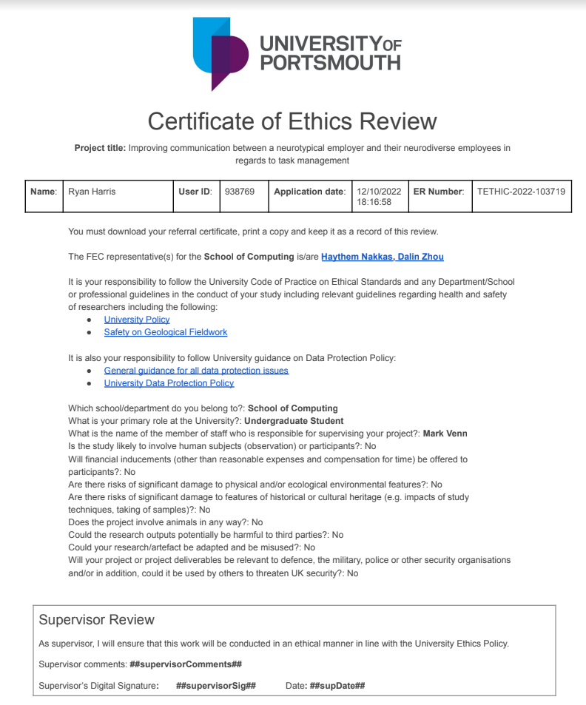

# Appendix C Project Plan and Progress

# Appendix D Database Design